**Self-Reflection Survey Submission Screenshot:**

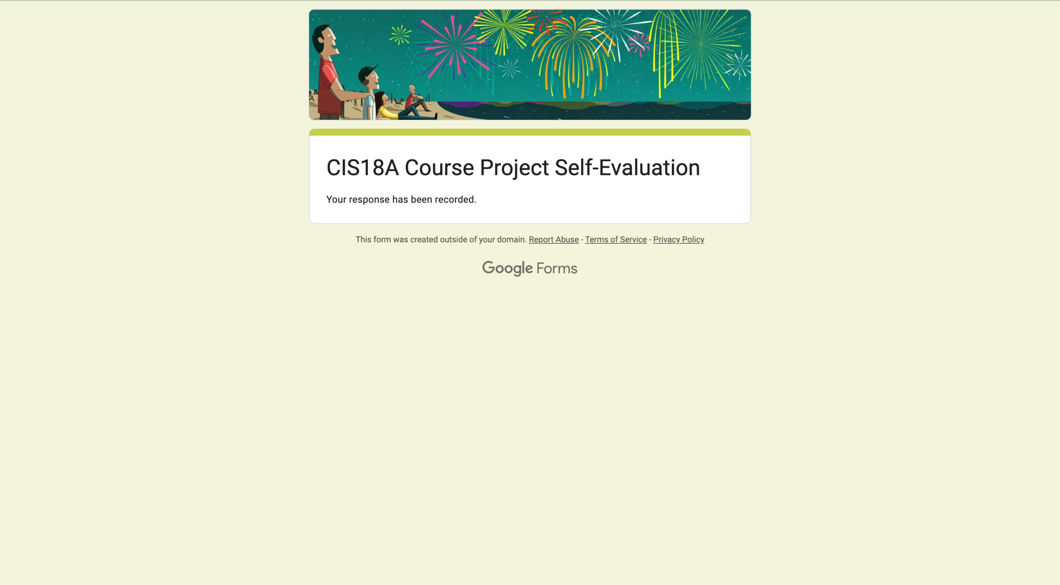

**GitHub Repository Link:**

<https://github.com/javdel3/CIS18A_Project.git>